Bahria University,

Karachi Campus



LAB EXPERIMENT NO.

_______8_______

LIST OF TASKS

|  |  |
| --- | --- |
| TASK NO | OBJECTIVE |
| 1 | **Create an application which can manipulate a Clock object having hours, minutes and seconds as integer attributes. Your application must have only two activities as follows:**   * 1. ***ClockActivity:***   **Shows the clock contents and the gives field selection by radio buttons for update. Creates new Clock object, displays it and send it to UpdateActivity for update.**   * 1. ***UpdateActivity:***   **Gets data for the selected field. Saves the field in the object and send back object to ClockActivity.** |

Submitted On:

___________

(Date: 13/5/23)

**Lab # 8**

**Tasks:**

1. Using Toast class, create an application which can demonstrate all callbacks of a ***started*** service.

**Code:**

public class AndriodServices extends Service {  
 private MediaPlayer player;  
 @Override  
 public int onStartCommand(Intent intent, int flags, int startId) {  
 player=MediaPlayer.*create*(this, Settings.System.*DEFAULT_ALARM_ALERT_URI*);  
 player.setLooping(true);  
 player.start();  
 Toast.*makeText*(this, "Service Started", Toast.*LENGTH_SHORT*).show();  
 return *START_STICKY*;  
 }  
 @Override  
 public void onDestroy() {  
 super.onDestroy();  
 player.stop();  
 Toast.*makeText*(this, "Service Destroyed", Toast.*LENGTH_SHORT*).show();  
 }  
 @Nullable  
 @Override  
 public IBinder onBind(Intent intent) {  
 return null;  
 }  
}

public class MainActivity extends AppCompatActivity implements View.OnClickListener {

private Button start,stop,start1,stop1;

@Override

protected void onCreate(Bundle savedInstanceState) {

super.onCreate(savedInstanceState);

setContentView(R.layout.*activity_main*);

start=findViewById(R.id.*buttonstart*);

stop=findViewById(R.id.*buttonstop*);

start1=findViewById(R.id.*buttonstart1*);

stop1=findViewById(R.id.*buttonstop1*);

start.setOnClickListener(this);

stop.setOnClickListener(this);

start1.setOnClickListener(this);

stop1.setOnClickListener(this);

}

@Override

public void onClick(View view) {

if (view ==start)

{

startService(new Intent(this,AndriodServices.class));

}

else if (view ==stop)

{

stopService(new Intent(this,AndriodServices.class));

}

else if (view ==start1)

{

startService(new Intent(this,CounterServices.class));

}

else if (view ==stop1)

{

stopService(new Intent(this,CounterServices.class));

}

}

}

<service android:name=".AndriodServices"/>

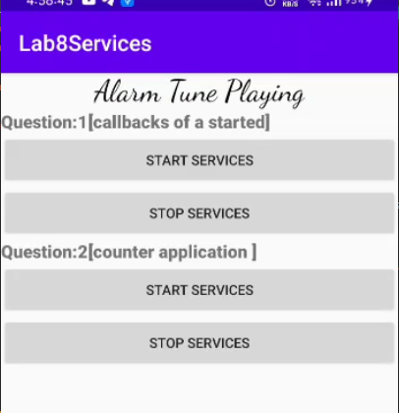OUTPUT:



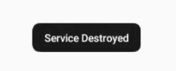



1. Using Toast class, create counter application which can demonstrate all callbacks of a ***started*** service.

CODE:

public class CounterServices extends Service {

private MediaPlayer player;

private static int *count*=0;

@Override

public int onStartCommand(Intent intent, int flags, int startId) {

player=MediaPlayer.*create*(this, Settings.System.*DEFAULT_ALARM_ALERT_URI*);

player.setLooping(true);

player.start();

*count*++;

Toast.*makeText*(this, "Service Started:"+*count*, Toast.*LENGTH_SHORT*).show();

return *START_STICKY*;

}

@Override

public void onDestroy() {

super.onDestroy();

player.stop();

Toast.*makeText*(this, "Service Destroyed:"+*count*, Toast.*LENGTH_SHORT*).show();

*count*--;

}

@Nullable

@Override

public IBinder onBind(Intent intent) {

return null;

}

}

<service android:name=".CounterServices"/>

**OUTPUT:**

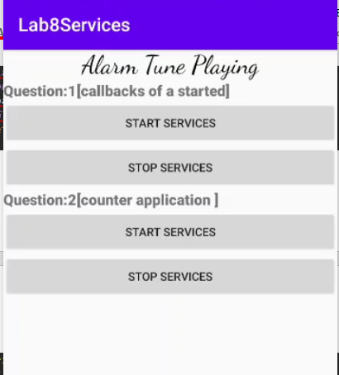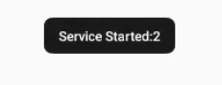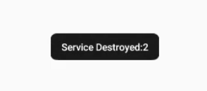

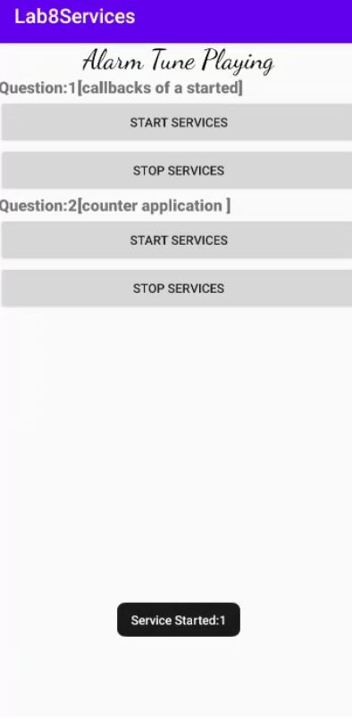**LAYOUT:**

